**Calculation of NPV, IRR and BCR**

1. **Net Project Value (NPV) Calculation:**

NPV is the difference between the present value of cash inflows and the present value of cash outflows. NPV compares the value of a dollar today to the value of that same dollar in the future, taking inflation and returns into account. NPV analysis is sensitive to the reliability of future cash inflows that an investment or project will yield and is used in capital budgeting to assess the profitability of a project.

Formula: NPV is calculated using the following formula:

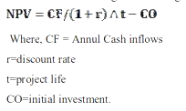

1. **Internal Rate of Return (IRR):**

Internal Rate of Return (IRR) is the discount rate that equates the NPV of an investment opportunity with 0. The IRR is always expressed as a percentage. For a project to be acceptable under the IRR method, the discount rate must exceed the project’s cost of capital, otherwise known as the hurdle rate.

Decision Criteria:

¬ If the IRR is greater than cost of capital, accept the project.

¬ If the IRR is less than cost of capital, reject the project.

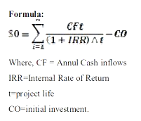

1. **Benefit: Cost Ratio (BCR):**

The information to calculate the Benefit: Cost Ratio (*BCR*) is collected in the course of completing the Project Assessment Form (PAF). The variables that feed into calculation of the Benefit: Cost Ratio are mostly specified as proportions, and are included in the Index multiplicatively. Indeed, given the way the formula is structured, introducing weights into the process would conflict with the logic of the approach.

The *BCR* is calculated as follows:

